Link to Repository: https://github.com/SYnthestic/INF1103lab2
Docker Mount Success – remembers inventory.json | 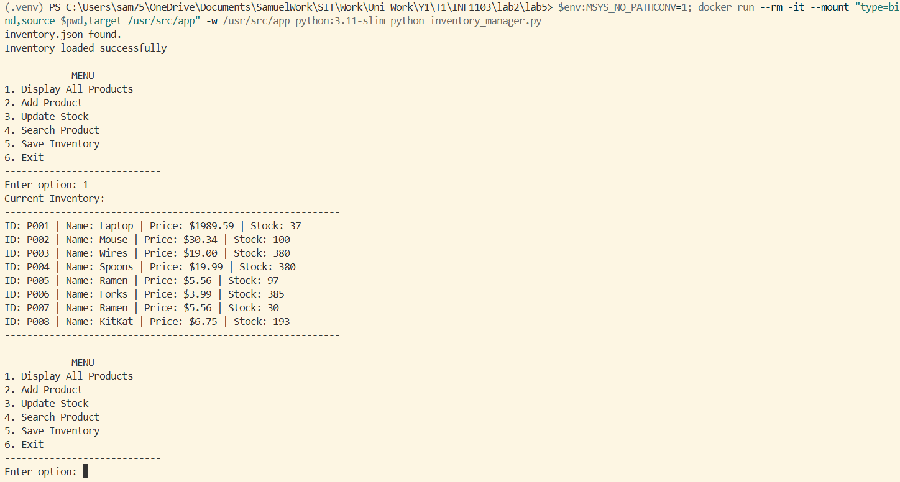
Docker Mount Success  Option 2 and 3 | 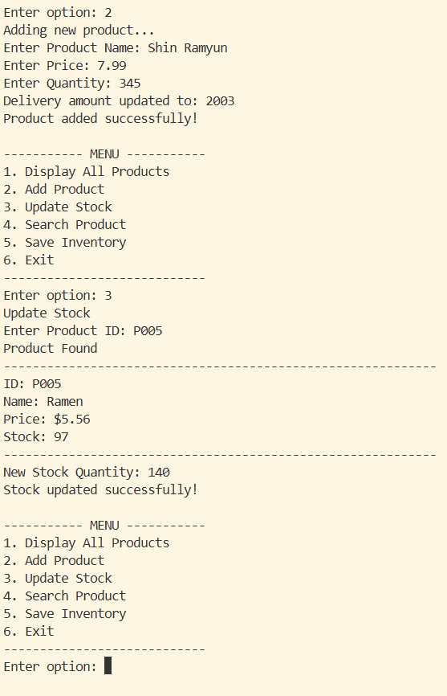
Docker Mount Success Option 3 – Error Checking | 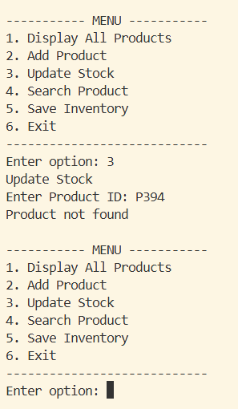
Docker Mount Success  Option 4 – with error checkings | 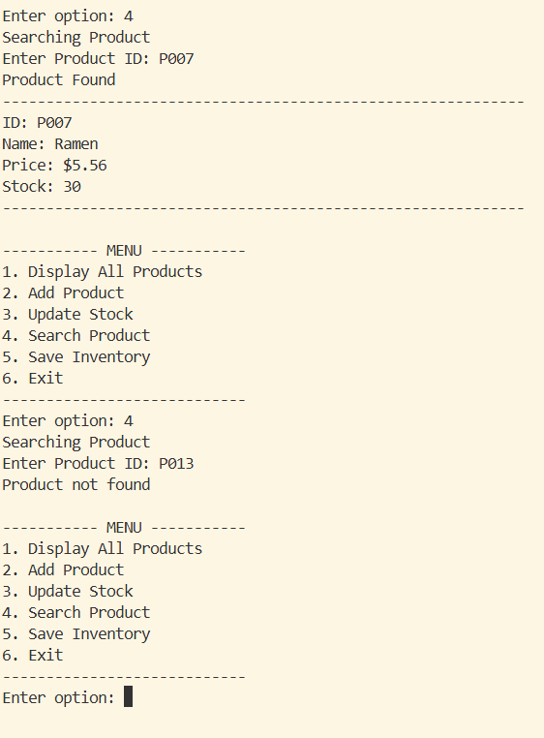
Docker Mount Success  Option 5 and 6 | 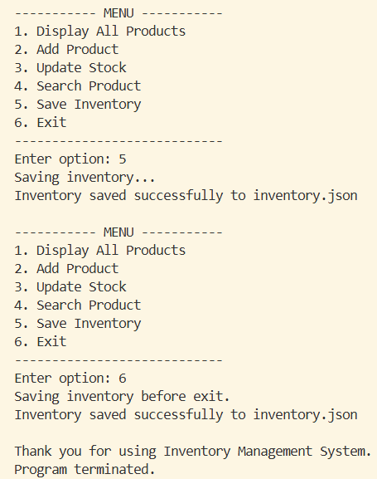
Docker Build Image | 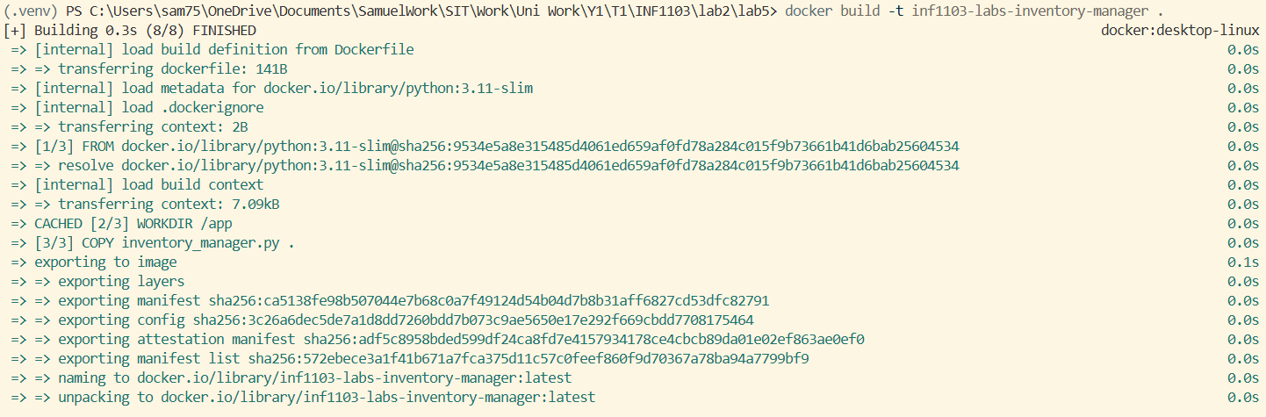
Docker Image Build Success | 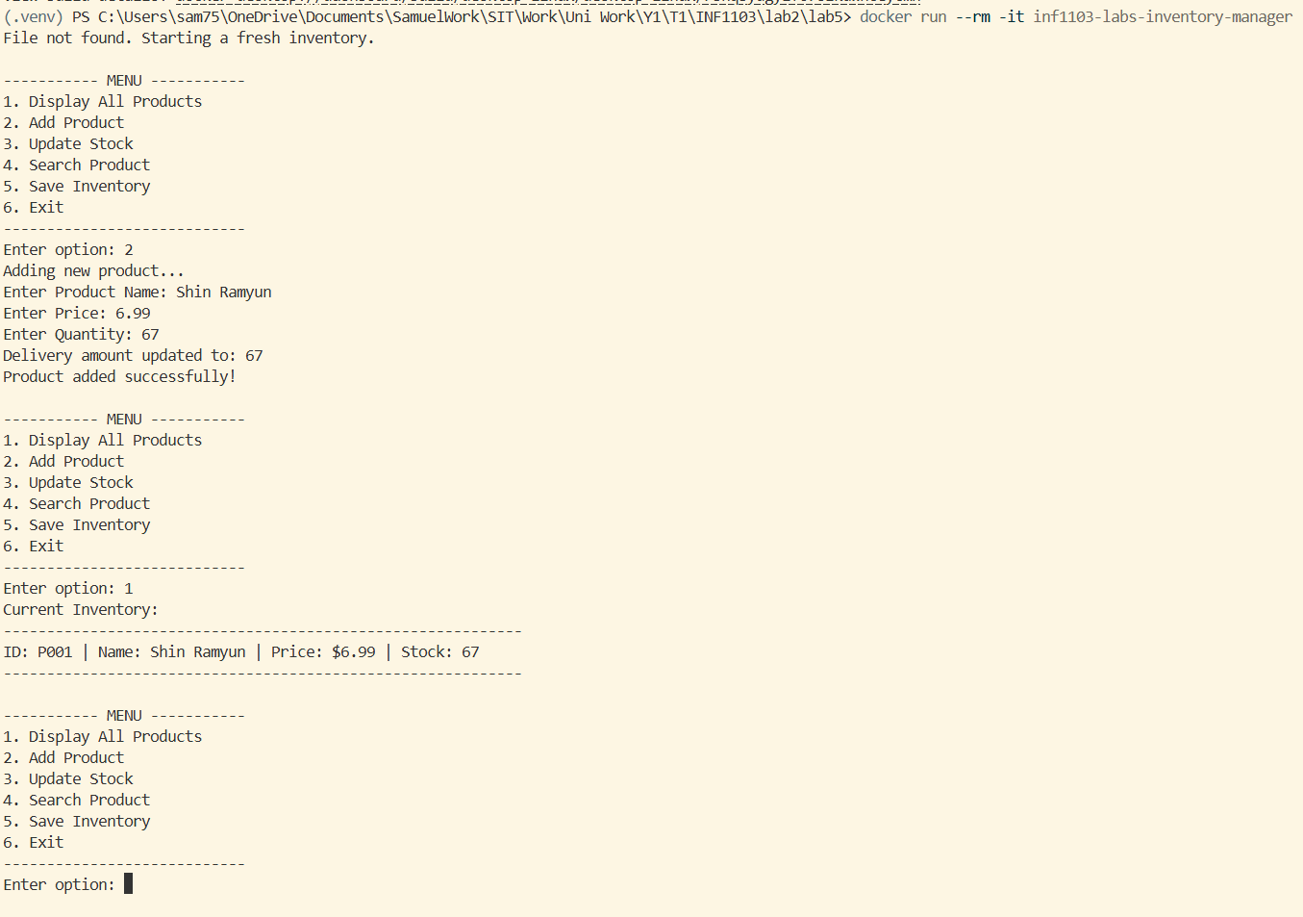
Docker Image | 